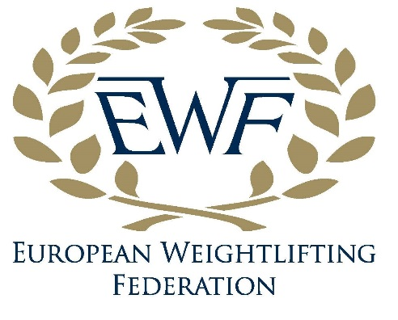
Weightlifting
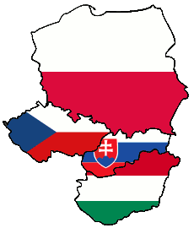
VISEGRAD 4 CUP

03. - 05. November 2017

Prague (Czech Republic)
1. Competition Regulation
The 2017 Visegrad 4 Cup(V 4 Cup) will follow Technical and Competition Rules and Regulations (TCRR) of the International Weightlifting Federation (IWF). Exception is the time between the weigh-in and start of competition of men (see paragraph 6. Time schedule).
2. Terms and Condition of Participation
Accredited participants (athletes, Team Officials, Technical Officials (TOs) media, guests, etc.):
- Should acknowledge and fully comply with IWF TCRR and Anti-Doping Policy (ADP)
- Should abide by all reasonable directions given by the Organizing Committee (OC)
- Should agree to be filmed, televised, photographed, interviewed and otherwise recorded during the Event for the purpose of the media coverage and the promotion of the weightlifting sport
- Should agree that any of the above mentioned images may be used by OC
- Should accept any prize or award given by OCV 4 Cupor sponsors and will attend all special award ceremonies where prizes or awards are presented
- Should participate in the Event at their own risk and take all reasonable measures to protect themselves from any risk
- Are responsible for all property they bring into the Event and that the OC shall have no responsibility in any loss or damage of this property
- Should irrevocably release IWF from liability for any loss, injury or damage that they may suffer in relation to their participation in the Event
- Should guarantee that the junior participants participate in the Event with the permission of their parent(s) or guardian(s) in case they are minors
- Federations participating in the V 4 Cup do so at their own risk. All participating Federations must undertake full moral and financial responsibility of their registered/accredited delegates with regard to their health and wellness and in case of accidents or damages not attributable to the OC.

3. Eligibility
Participating athletes: Junior (M and F) - 18-20 years of age (born between 1999 and 1997)
Senior (M and F) – older than 20 years of age (born before 1997)
Each Federation shall participated with team consist of 1 female junior lifters, 1 male junior lifters, 2 senior female, 2 senior male, 2 coaches and 1 leader of the delegation.

4. Date and venue
Date and place: 03. - 05. November 2017, Prague, Czech Republic
Competition, training venue and accommodation:
Sports Centre of the Czech Ministry of Interior, Prague, Za Císařským mlýnem Street 1063, 170 06, Prague 7
Training venue will be available for athletes and coaches from 03rd November 2017
5. Events and awards
The team competition, optionally in bodyweight categories according to IWF TCRR.
The best three lifters, according to Sinclairs points, evaluated from Female Juniors, Female Seniors, Male Juniors and Male Seniors will be awarded by Cup, medals and gifts.
The best National Team evaluated according to Sinclair points will be awarded by V 4 Cup.
All participants received the promotional gifts.

6. Time schedule
Friday, 03rd November
- 12:00 a.m. – Arrivals of abroad participants and acreditation within the Centre of Sports
- 02:00 p.m. – Antidoping and Sport Nourishment seminar in Weightlifting Trainng hall within the Centre of Sports
- 07:00 p.m. - Technical meeting, Restaurant „U Pramene“, Goetheho Street (10 min. walk from Sports Center)
- 08:00 p.m. – Welcome Dinner (at the same Restaurant above)
Saturday, 04th November
- 09:00 - 10:00 a.m.–Weight-in of all groupes
- 11:00 a.m. - Start of the competition Females Junior and Senior
- 12:00 a.m. - Start of the competition Males Junior and Senior
- 01:30 p.m.–Closing Ceremony with awarding the best athletes
- 02:00 p.m. – individual visit of the Prague City
- 06:00 p.m. – Closing Dinner
Sunday, 05th November
- till 09:30 a.m. – Breakfest
- 11:00 a.m.– Departure of the participants

7. Barbell
The IWF approved ELEIKO barbells will be used in competitions and training.

8. Deadlines
Forms must be sent before the 16th of Oktober 2017.
Must be sent to the following e-mail addresses:
pavel.filipovic@csmv.cz(Organizing Committee) and
vzpirani@cstv.cz(CWA).

9. Financial conditions
Participated Federations shall provide all traveling cost to and from Prague.
Accommodation and the board for participantswill be provide by OC.

10. Insurance
All participating Federations must undertake full moral and financial responsibility of their registered/accredited delegates with regard to their health and wellness and in case of accidents or damages not attributable to the OC.

11. Notes
Information about Prague:
http://www.praha.eu
http://cs.wikipedia.org/wiki/Praha
Average temperature foreseen in Prague during the Visegrad 4 Cup is 12° C.
Electricity: 220 V

